We have learnt the whole objective of LR if to find otpimal W and we have a weight vector for that W.

i.e. each feature is assigned weight.

The assumption in LR is that all the features are independent.

And so feature importance in LR can be determined by Wj’s.

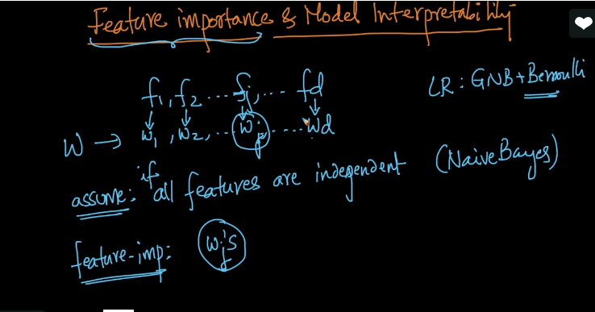

In KNN we used Forward feature selection and this method is algorithm independent and can be used in all algorithms to find feature importance.

In NB we used to find feature importance using conditional probability i.e. more the probability more important the feature is.

In LR we determine it by Wj’s.

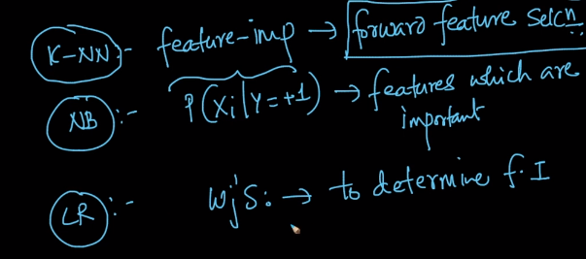

We take absolute values for Wj and when Wj increase it will directly impact the multiplication of WtXq because it is nothing but sum of all Wj.Xqj

And hence if Wj is positive and large so P(Yq = +1) gets high and vice versa.

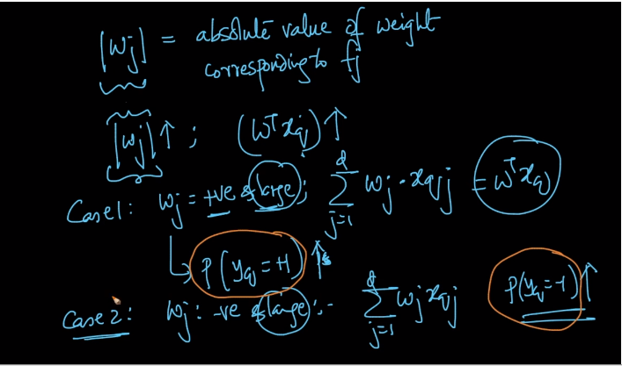

For example we need to determine between male and female.

So hair length can be one of the important feature and hence Whl is high and -ive means P(Yq = -1) is high.

And Height can also be one of the important feature i.e. if W(height) is +ive and high means P(Yq = +1) is high.

Here +1 is male and -1 is Female.

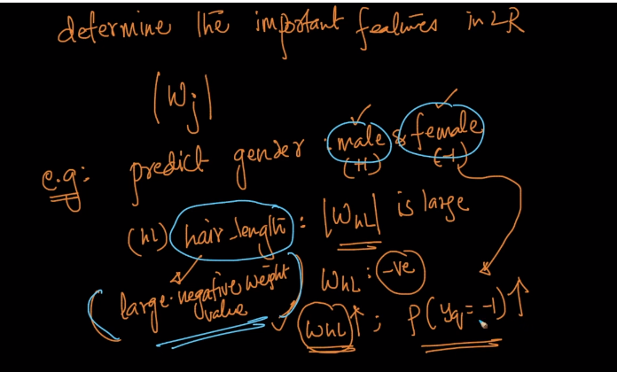

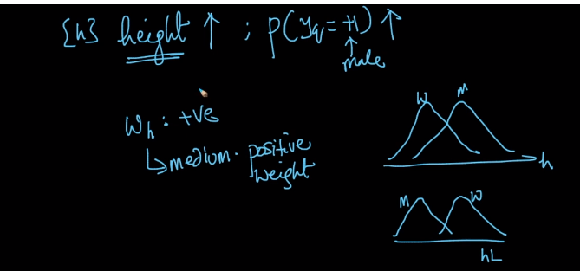

]

So using this feature importance we can show interpretability means we can give reasonings to our selected class label.

Suppose we determind Yq as positive so we can say that since W(height) is high for Xq it is a boy.

SO in this way if we have 1000 features so we can just take top 5 features using feature importance and give reasoning based on them.

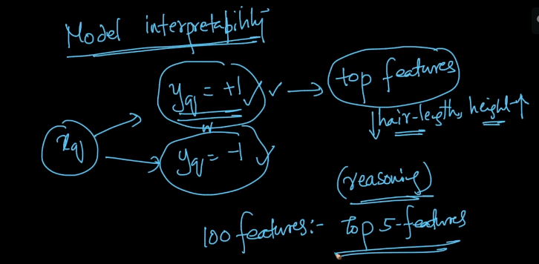

Comments:

